Press List Component

This Component will use to show the press-release listing.

We just need to add or drag this component.

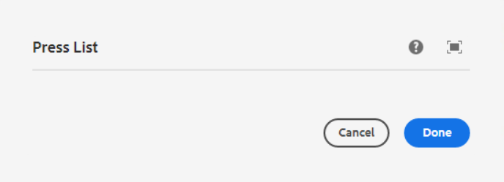

**Page Reference 1** - <https://www.ancestry.com/corporate/newsroom/press-releases>

**AEM URL 1** - <https://author-ancestry-dev2.adobecqms.net/content/ancestry-corp/us/en/newsroom/press-releases.html?wcmmode=disabled>

In this component, below list of fields are visible

* **Year filter dropdown** – Able to find any press-release using year
* **Press Release listing section** – When we create a new press-release using a blog template then that press-release will be shown here and also the list of press-releases are visible.
* **Pagination** – Using pagination, we can able to see all the press-release while clicking on the pagination number.

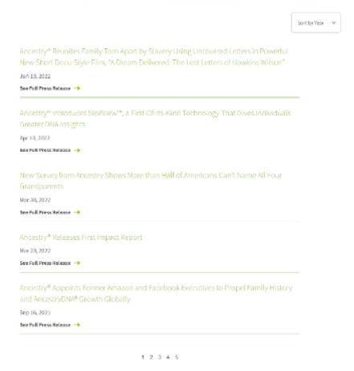

___________________________________________________________________

We can use the Country Site template to design a press release archive page inside that we will use the press list component

1. **AU site Template**

**Page Reference 2** - <https://www.ancestry.com/corporate/au/press-releases>

**AEM URL 2** - <https://author-ancestry-dev2.adobecqms.net/content/ancestry-corp/us/en/global-newsrooms/au/press-releases.html?wcmmode=disabled>

1. **CA site Template**

**Page Reference 2** - <https://www.ancestry.com/corporate/ca/press-releases>

**AEM URL 2** - <https://author-ancestry-dev2.adobecqms.net/content/ancestry-corp/us/en/global-newsrooms/ca/press-releases.html?wcmmode=disabled>

1. **UK site Template**

**Page Reference 2** - [https://www.ancestry.com/corporate/uk/press-releases](https://www.ancestry.com/corporate/ik/press-releases)

**AEM URL 2** - <https://author-ancestry-dev2.adobecqms.net/content/ancestry-corp/us/en/global-newsrooms/uk/press-releases.html?wcmmode=disabled>

On Country sites templates, in press list component, below list of fields are visible

* **Year filter dropdown** – Able to find any press-release using year
* **Press Release listing section** – When we create a new press release using a respective press release template (AU, CA, UK) then that press release will be shown here and also the list of press releases are visible.
* **Pagination** – Using pagination, we can able to see all the press-release while clicking on the pagination number.